TRYHACKME LAB REPORT

Further Nmap
Internship: DG Interns HUB — Week 2
Domain: Cybersecurity — Network Traffic Analysis and Reconnaissance
Platform: TryHackMe
Lab Name: Further Nmap

1. Aim
To understand advanced Nmap scanning techniques, learn how different TCP scan types work, investigate firewall behaviour, and interpret network responses during authorized security testing.

2. Objectives
- Understand the purpose and operation of Nmap.
- Learn different TCP scan techniques and their differences.
- Understand how firewalls influence scan results.
- Learn techniques used to interpret network responses.
- Practise scanning within an authorized lab environment.
- Understand how network reconnaissance can be identified during security monitoring.

3. Introduction
Nmap stands for Network Mapper. It is a free and open-source tool used for network discovery and security auditing.
Nmap helps security professionals identify active hosts, discover open ports, detect services and their versions, and estimate operating systems.
It is useful in penetration testing, network administration, vulnerability assessment and security monitoring.

4. Theory

4.1 TCP SYN Scan
The SYN scan uses the -sS option.
- Sends TCP SYN packets to target ports.
- An open TCP port commonly responds with SYN-ACK.
- A closed TCP port commonly responds with RST.
- A filtered port may not respond or may return an ICMP error.
- It usually does not complete the full TCP handshake for open ports.
Example:
sudo nmap -sS -p 22,80,443 TARGET_IP

4.2 TCP Connect Scan
The TCP connect scan uses the -sT option.
- Uses the operating system's connection API.
- Attempts to establish a complete TCP connection.
- Useful when raw-packet privileges are unavailable.
- Completed connections may be recorded by the target service.
Example:
nmap -sT -p 22,80,443 TARGET_IP

4.3 TCP NULL, FIN and Xmas Scans
These scan types use unusual TCP flag combinations.
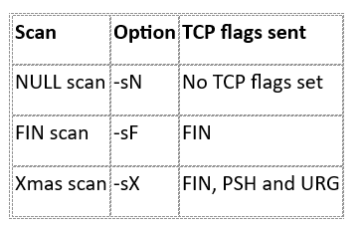
These scans examine how targets respond to unusual TCP segments. Their results can be unreliable on some operating systems and networks. Firewalls may also drop the probes.

4.4 TCP ACK Scan
The ACK scan uses the -sA option.
- Sends TCP packets with the ACK flag set.
- Helps investigate firewall filtering behaviour.
- Can help distinguish filtered from unfiltered ports.
- Does not reliably determine whether a port is open or closed.
Example:
sudo nmap -sA -p 80,443 TARGET_IP

4.5 Service and Version Detection
The -sV option attempts to identify services and software versions running on open ports.
Example:
nmap -sV TARGET_IP
Version detection helps administrators identify outdated or unexpected services that may need further security review.

4.6 Firewall Evasion Concepts
Some Nmap techniques modify how probes are sent to examine network filtering behaviour.
Examples include packet fragmentation, decoy addresses and alternative source ports. These techniques can affect how probes appear to network monitoring systems.
They should only be studied and tested within the scope of an authorized lab. They do not guarantee that a scan will bypass a firewall or remain undetected.

5. Tools and Environment

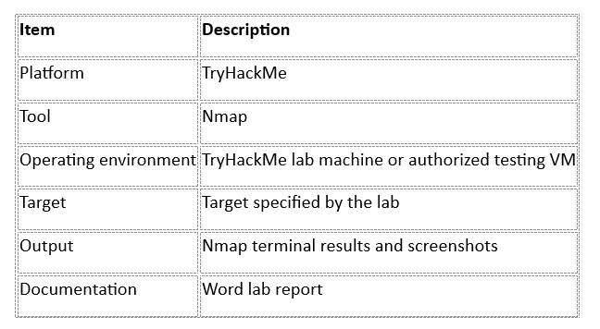

6. Practical Methodology

Step 1: Access the Lab
- Sign in to TryHackMe.
- Open the Further Nmap room.
- Read the task descriptions and lab instructions.
- Start the required machine if the room provides one.

Step 2: Understand the Target
Identify the authorized target IP address and confirm the lab environment is ready.
Record the target address in your notes. Do not substitute an unrelated public system.

Step 3: Perform the Required Scans
Follow the scan instructions provided in the room. Where relevant, compare SYN, connect, NULL, FIN, Xmas and ACK scan behaviour.
Record the actual command, output and interpretation for each completed task.

Step 4: Examine Results
For each scan, record:
- The scan type used.
- The ports examined.
- The observed port states.
- Any detected services or versions.
- Whether responses suggest filtering.
- Any limitations or inconclusive results.

Step 5: Save Evidence
Capture screenshots of important commands, scan results and completed room tasks.
Keep the evidence in the Week 2 Findings folder and refer to the relevant filenames in this report.

7. Results and Findings
Complete this table using your actual TryHackMe results.
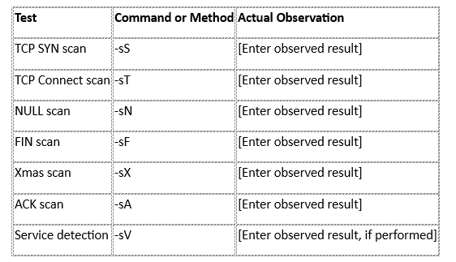
Not every scan is necessarily required by every room task. Include only tests you actually performed.

Key Observations
- Different scan types generate different TCP flag combinations.
- Open, closed and filtered ports can produce different network responses.
- Firewalls and operating systems can influence scan results.
- Service detection provides information beyond basic port discovery.
- Scan results must be interpreted in context rather than treated as definitive proof of a vulnerability.

8. Security Relevance for SOC Analysts
Nmap knowledge helps SOC analysts recognize reconnaissance activity in network traffic.
During an investigation, an analyst may look for:
- One source contacting many ports on a host.
- One source probing multiple hosts.
- Repeated SYN packets without completed connections.
- Unusual TCP flag combinations.
- Repeated connections to unexpected services.
These patterns can also result from authorized vulnerability assessments or routine administration. Analysts should verify the source, timing, authorization and surrounding evidence before classifying activity as malicious.

9. Challenges and Limitations
- Firewall rules may prevent probes from reaching a target.
- Some systems respond differently to unusual TCP flags.
- Service detection may not identify a precise version.
- Network timeouts may produce inconclusive results.
- Results depend on the target configuration and lab environment.

10. Learning Outcomes
After completing the lab, the intended learning outcomes are:
- Understand advanced Nmap scan concepts.
- Recognize common TCP flag combinations.
- Interpret basic port states and network responses.
- Understand how firewalls influence reconnaissance.
- Recognize potential scan patterns relevant to SOC monitoring.
- Document security testing results clearly.

11. Evidence Checklist
- Screenshot of the Further Nmap room.
- Screenshot of completed tasks.
- Screenshots of relevant scan commands and outputs.
- Actual results recorded in the findings table.
- Room answers recorded in the report.
- Evidence files saved in the Week 2 Findings folder.

12. Conclusion
The Further Nmap lab develops an understanding of advanced network reconnaissance and TCP scanning behaviour. It explains how different scan types use packet flags and how network devices may respond to those probes.
These concepts are useful in authorized security testing and SOC investigations, where understanding scan patterns can help identify possible reconnaissance activity.


